End-to-End Retail Sales Analytics Pipeline using Microsoft Fabric and Power BI
By: | Project Date:
Dikshaynta Shrestha | 4th March, 2026 - 11th March, 2026
Junior Power BI Developer | Personal Project

Tools used:
- Microsoft Fabric
- Microsoft Power BI
- PySpark
- Delta Lake
- Mircosoft Excel

Table of Contents:

- Introduction
- Project Objectives
- Technology Stack
- Dataset Description
- Architecture Overview
- Data Engineering pipeline
- Data Modeling
- Semantic Model Creation
- Dashboard Development
- Business Insights
- Challenges and Solutions
- Future Improvemnets
- Conclusion

- INTRODUCTION

This project presents and end-to-end analytical solution built on the Microsoft data platform using Mircrosoft Fabric and Microsoft Power BI. The goal of the project is to transform raw sales data into meaningful insights through a structured data pipeline and interactive dashboards.

The process starts with raw sales data stored in Excel files, which is ingested into a Lakehouse environment in Microsoft Fabric. The data is then processed and transformed using PySpark notebooks, where data cleaning, transformation, and preparation are performed to make the dataset suitable for analysis.
The project follows the Medallion Architecture, which organizes the data pipeline into three layers: Bronze, Silver, and Gold. The Bronze layer stores raw data, the Silver layer contains cleaned and transformed data, and the Gold layer provides business-ready datasets optimized for analytics and reporting.

Finally, the curated data from Gold layer is connected to Power BI, where interactive dashboards and visual reports are created to analyze sales performance and generate business insights.

- PROJECT OBJECTIVES

The main objective of this project is to build an end-to-end data analytics solution using Microsoft Fabric and Microsoft Power BI. The project demonstrates how raw sales data can be ingested, processed, and transformed into meaningful insights through a structured data pipeline and modern data architecture.

Key objectives of the project include:
- Build a complete data pipeline using Microsoft Fabric.
- Implement Medallion Architecture for structured data processing.
- Transform raw Excel data into clean and analytics-ready datasets using PySpark notebooks.
- Develop an interactive Power BI dashboard to visualize business insights and sales performance.
- Demonstrate real-world data engineering and BI workflow from data ingestion to reporting.

- TECHNOLOGY STACK
Technology | Purpose
Microsoft Fabric | Data Platform
Lakehouse | Data storage
PySpark | Data transformation
Delta Lake | Data versioning
Power BI | Data visualization
Excel | Source dataset

- DATASET DESCRIPTION

The dataset used in this project contains sales transaction data along with supporting dimension tables that help analyze business performance from multiple perspectives such as customers, products, stores, and time. This structured dataset allows the creation of meaningful relationships between tables, enabling deeper analytical insights in Microsoft Power BI after processing in Microsoft Fabric.
The dataset includes sales records across multiple cities and store locations, which allows geographic analysis of sales performance. This helps in identifying regional trends, high-performing locations, and variations in customer behaviour across different cities.

Tables Used in the Project
Sales_Fact | Contains transaction-level sales data including order details, sales amount,  and profit.
Customers | Stores customer-related information such as customer segment and demographic  details.
Products | Contains product catalog information including product category and product  detiail.
Stores | Includes store location data used for geographic sales analysis.
Date_Dimension | Calendar table used for time-based analysis such as daily, monthly, or yearly trends.

Key attributes in the Dataset
- Order Date - Used for analyzing sales trends over time.
- Customer Segment - Helps understand purchasing patterns among differnet customer groups.
- Product Category - Enables analysis of which product grouos generate the most sales.
- Sales Amount - Represents the revenue generated from each transaction.
- Profit - Shows the profitablity of sales and helps evaluate business performance.

This dataset structure enables multi-dimensional analysis, allowing insights based on time, geography, customer segments, and product categories, making it suitable for building interactive dashboards and business intelligence reports.

- ARCHITECTURE OVERVIEW

- Data Architecture
The project follows a structured data pipeline architecture built using Microsoft Fabric and Microsoft Power BI. The pipeline starts with raw sales data and gradually transforms it into analytics-ready datasets that can be used for reporting and visualization.
The workflow begins with Excel datasets, which act as the raw data source. These files are ingested into the Fabric lakehouse, where data storage and processing take place.
Next, PySpark notebooks are used to perform ETL (Extract, Transform, Load) operations. In this stage, the data is processed and structured through different layers of the Medallion architecture, ensuring proper data quality and organization.
The processed data then moves through Bronze, Silver, and Gold tables, each serving a specific purpose in the transformation process. The final curated data is used to create a Semantic Model, which defines relationships and measures required for reporting.
Finally, the semantic model is connected to Power BI, where interactive dashboards are created to visualize sales trends, customer insights, and business performance.
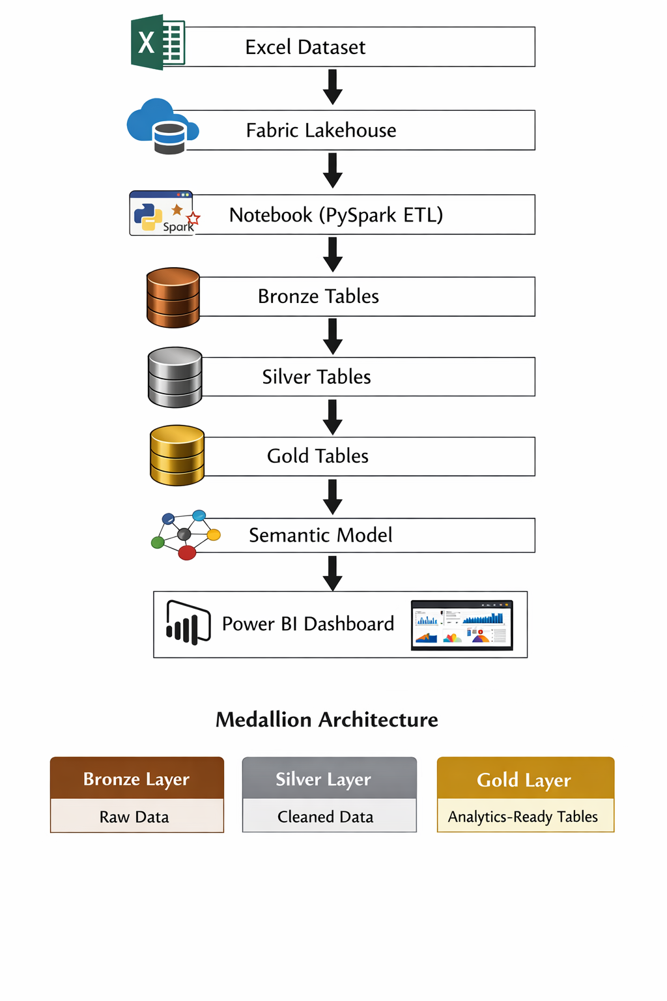

- Medallion Architecture
This project implements the medallion Architecture, a modern data design pattern widely used in lakehouse-based data platforms. This architecture organizes data into three layers to improve data quality and performance.
- Bronze Layer - Raw Data
The Bronze layer stores the raw data exactly as it is ingested from the source (Excel files).
No major transformations are applied here. This layer acts as the foundation of the pipeline and preserves the original data for traceability and auditing.
- Silver Layer - Cleaned and Transformed Data
In the Silver Layer, the raw data is cleaned, validated, and transformed using PySpark notebooks. Data inconsistencies, missing values, and formatting issues are handled here, producing structured and reliable datasets.
- Gold Layer - Anlytics-Ready Data
The Gold layer contains business-ready tables optimized for analytics and reporting. Data is often aggregated and structured in a way that makes it easier to build dashboards and perform business analysis.

Using this layered approach ensures that the data pipeline remains scalable, organized, and efficient for analytical workloads.

- DATA ENGINEERING PIPELINE

The data processing in this project is handled using PySpark notebooks in Microsoft Fabric, where the data moves through multiple stages following the Medallion Architecture. Each step ensures that the raw data is gradually transformed into structured and analytics-ready datasets.

Step 1 : Data Ingestion
In this step, the raw Excel sales dataset is loaded into the Fabric Lakehouse environment. PySpark is used to read the Excelfiles and convert them into Spark DataFrames so they can be processed efficiently within the notebook environment.

Step 2 : Bronze Layer (Raw Data Storage)
The ingestion is stored in the Bronze Layer without significant transformation. This layer keeps the original raw data as it is received from the source. The purpose of this layer is to maintain a reliable copy of the source data for traceability and future reprocessing if needed.

Step 3 : Silver Layer (Data Cleaning and Transformation)
In the Silver Layer, the data undergoes cleaning and transformation. Tasks such as handling missing values, correcting data types, removing duplicates, and standardizing column names are performed using PySpark operations. This step ensures the dataset becomes consistent and reliable for further analysis.

Step 4 : Gold Layer (Business-Level Data Modeling)
The cleaned data is then transformed into business-ready tables in the Gold Layer. Here, the data is structured for analytical purposes by creating fact and dimension tables, performing aggregations, and preparing datasets that are optimized for reporting and dashboards.

- SEMANTIC MODEL CREATION

After preparing the Gold layer tables, a smenatic model was created in Microsoft Fabric using Direct Lake mode. Direct Lake allows Microsoft Power BI to query data directly from the Lakehouse without importing the data into Power BI, which improves performance and enables near real-time analytics.
The semanctic model is built by conecting the Gold-level fact table with several dimension tables to create a structured data ,odel suitable for analysis and reporting.

Tables Used in the Semantic Model

- Sales_Gold - Fact table containing transaction-level sales data such as sales amount, profit, and order details.
- Customers - Dimension table containing customer information such as customer segment and demographics.
- Products - Dimension table containing product details including product category and product names.
- Stores - Dimension table containing store location information used for geographic analysis.
- Date_Dimension - Calendar table used for time-based analysis like daily, monthly, and yearly trends.

Relationships Created

Relationships were created between the Sales_Gold fact table and the dimension tables to allow data to be analyzed from multiple perspectives.
From | To
Sales_Gold | Customers
Sales_Gold | Products
Sales_Gold | Stores
Sales_Gold | Date_Dimension

Each relationship connects a foreign key in the Sales_Gold table with the corresponding primary key in the dimension table, enabling filtering and aggregation acress different business dimensions.

Star Schema Model

By organizing the data in this way, the model forms a Star Schema, where Sales_Gold acts as the central fact table and the other tables act as dimension tables surrounding it.
This structue improves query performance, simplifies reporting, and makes it easier to build dashboards, as users can analyze sales data based on customers, products, store loactions, and time periods.

- DASHBOARD DEVELOPMENT

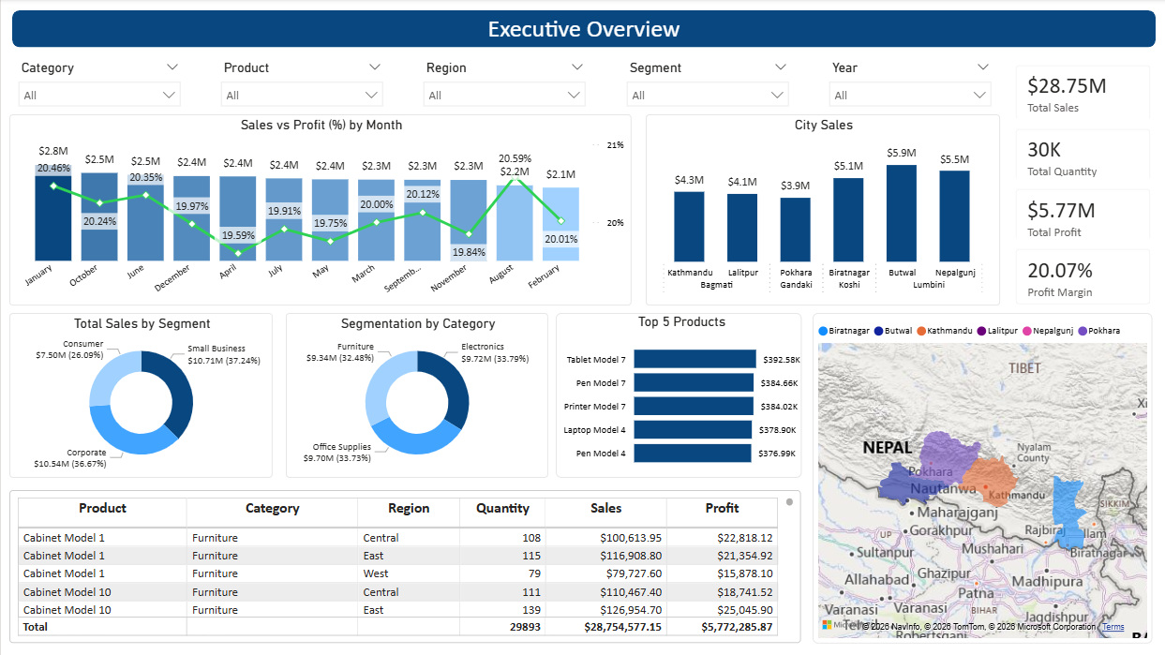

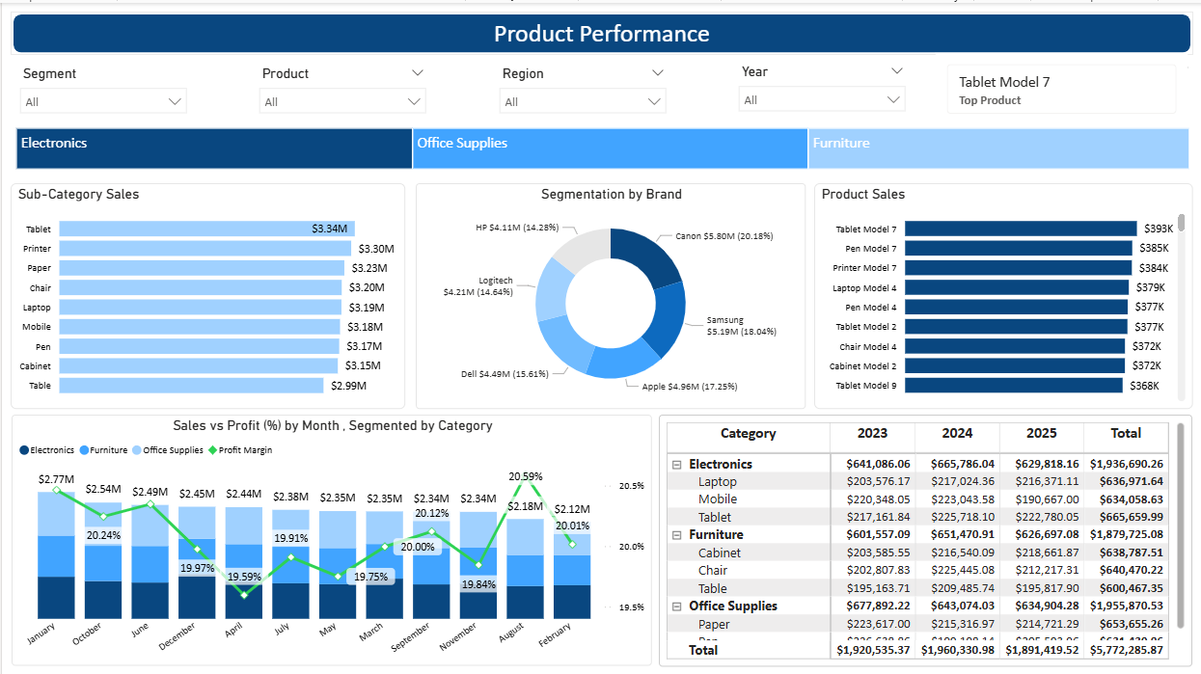
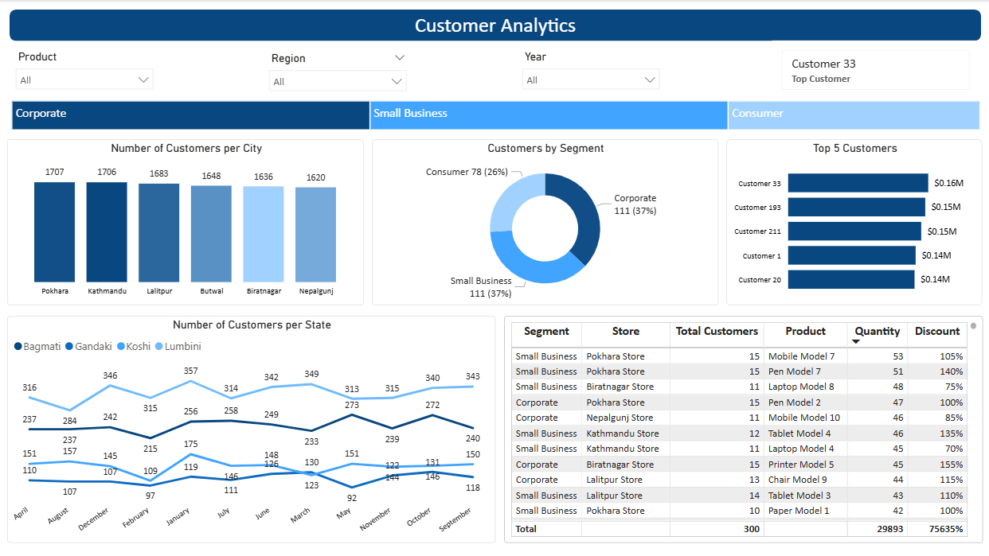

The dashboard was developed in Microsoft Power BI to provide a clear and interactive view of sales data across different perspectives. It is divided into three main pages, each focusing on a specific are of analysis.

Page 1 : Executive Overview
This page provides a high-level summary of overall business performance, allowing sgtakeholders to quickly understand key metrics and trends.
Includes:
- KPI Cards : Display key metrics such as total sales, total profit, and overall performance indicators.
- Sales Trend Analysis : Column and Line chart showing how sales changes over time (monthly trends) with profit margin.
- City Sales : Column chart showing the sales trend of each city and state with drill down feature.
- Category and Segment Performance : Visual comparison of sales across different product categories and segment to identify top cotributors.
- Top 5 products : Bar chart to represent the top products by sales.
- Geographic Sales Map : Map visualization showing sales distribution across multiple cities and regions for geographic insights.
- Table chart : Table visualization to represent the excel view for each data.

Page 2 : Product Analysis
This page focuses on product-level performance, helping identify which prudcts and categories drive revenue and profit.
Includes:
- Category and Subcategory Analysis : Breakdown os sales across categories and subcategories to understand product performance.
- Top Performing Products : Highlights products generating the highest sales or profit.
- Profit Contribution : Visuals showing how different products contribute to overall profitablility.

Page 3 : Customer Insights
This page provides insights into customer behaviour and regional performance, helping businesses better understand their customer base.
Includes:
- Customer Segmentation : Analysis based on customer groups to identify purchasing patterns.
- Regional Sales Analysis : Comparison of sales across differnet cities or regions to identify strong and weak markets.
- Top Customers : Identifies high-value customers who contribute the most to total revenue.

These dashboard pages together provide a comprehensive view of business performance, enabling users to explore data interactivity and make informed decisions.

- BUSINESS INSIGHTS
After processing the data and building in Microsoft Power BI, several important business insights were identified from the sales dataset. These insights help understand customer behaviour, product performance, and regional sales trends.

- Electronics category generated the highest revenue
The analysis show that the Electronics product category contributes the largest portion of total sales revenue. This indicates that customers tend to spend more on electronic products compared to other categories. Products in this category generally have higher price points, which increases the overall revenue even if the number of transactions is similar to other categories. This insights can help business foces on inventory planning, promotions, and marketing strategies around high-performing elecgtronic products.
- Certain cities contribute significantly to sales
The geographic analysis revealed that a few cities generate a large percentage of the total sales. These cities have higher customer demand and purchasing activity compared to others. Identifying these high-performing locations can help businesses optimize store operations, allocate inventory more efficiently, and focus marketing efforts in regions that drive the most revenue.
- A small percentage of customers drvive a large share of revenue
Customer analysis shows that a relatively small group of customers contributes a significant portion of the total revenue. This pattern is common in many businesses and reflects the Pareto principle (80/20 rule), where a minority of customers generate the majority of sales. Understanding these high-value customers can help businesses develop customer retention strategies, loyalty programs, and personalized marketing campaigns to maintain and increase revenue.

- Sales trends show seasonal patterns
Time-based analysis using the Date Dimension reveals that sales fluctuate during different periods of the year. Certain months or seasons experience higher sales due to factors such as holidays, promotional campaigns, or increased consumer demand. Recognizing these seasonal trends helps businesses plan inventory, schedule marketing campaigns, and prepare for peak sales periods, ensuring better operational efficiency and improved revenue planning.

- CHALLENGES AND SOLUTIONS
During the development of this project using Microsoft Fabric and Microsoft Power BI, severalpractical challenges were encountered while building the data pipeline and transforming the data. Below are some key challenges along with their solutions :
Challenge | Solution
Schema conflicts in Delta tables | Dropped and recreated tables before overwrite to  ensure schema consistency
Duplicate column names during joins | Used column aliasing and proper column selection  To avoid ambiguity
Large dataset processing | Utilized efficient PySpark transformations and  Optimized queries
Data type mismatches | Applied explicit data type casting during  transformation
Hnadling missing/null values | Used PySpark functions to clean or replace null  values
Creating relationships in semantic model | Ensured proper primary and foreign key mapping  Between tables
Slow dashboard performance | Optimized model using Star Schema and reduced  Unnecessary columns

These challenges helped in gaining hands-on experience with real-world data engineering problems, and the solutions ensured a smooth and efficient end-to-end data pipeline.

- FUTURE IMPROVEMENTS
While the current solution provides a complete end-to-end analytics pipeline, there are several enhancements that can further improve scalability, performance, and business value using Microsoft Fabric and Microsoft Power BI.
Some potential future improvements include:
- Implement real-time data ingestion
Integrate streaming data sources to process and analyze sales data in real-time instead of batch processing.
- Add machine learning for sales forecasting
Use predictive models to forecast future sales trends, helping in better decision-making and demand planning.
- Build automated data pipelines
Use pipelines in Fabric to automate data ingestion, transformation, and loading processes, reducing manual intervention.
- Implement Row-Level Security (RLS)
Apply RLS in power BI to restrict data access base on user roles, ensuring secure and personalized data visibility.
- Enhance dashboard interactivity
Add more advanced visuals, drill-through features, and dynamic filtering to improve user experience.

- Optimize performance
Further improve query performance by refining the data model, indexing strategies, and reducing data redundancy.

These improvements would make the solution more scalable, intelligent, and production-ready, aligning it closer to real-world enterprise data systems.

- CONCLUSION

This project demonstrates the implementation of a modern analytics pipeline using Microsoft Fabric and Microsoft Power BI. The solution highlights how raw data can be efficiently transformed into actionable insights through structured data engineering practices, the use of Medallion architecture, and scalable processing with PySpark.

It showcases a complete workflow from data ingestion to transformation and visualization, enabling a better understanding of sales performance, customer behaviour, and business trends through interactive dashboards. The use of a layered architecture ensures data quality, consistency, and scalability, making the solution reliable for analytical reporting.

Additionally, the project demonstrates key concepts such as data modeling (Star Schema), ETL processes, and dashboard design, which are essential in real-world data engineering and business intelligence scenarios. Overall, the project reflects a practical and industry-relevant approach to building data-driven solutions, leveraging modern tools and technologies to support informed decision-making.

